# Assignment 6: ***An interactive data visualization for UX designers****.*

**What is the Data visualization about?**

UX Designers have to be trained and well equipped with knowledge of the various User-centered Research and Design Methods. However, there are disparate sources for these methods and it is very difficult to get an overview of the many methods that designers can employ in their work. An online tool has been designed to facilitate users to look up brief information about the various design and research methods.

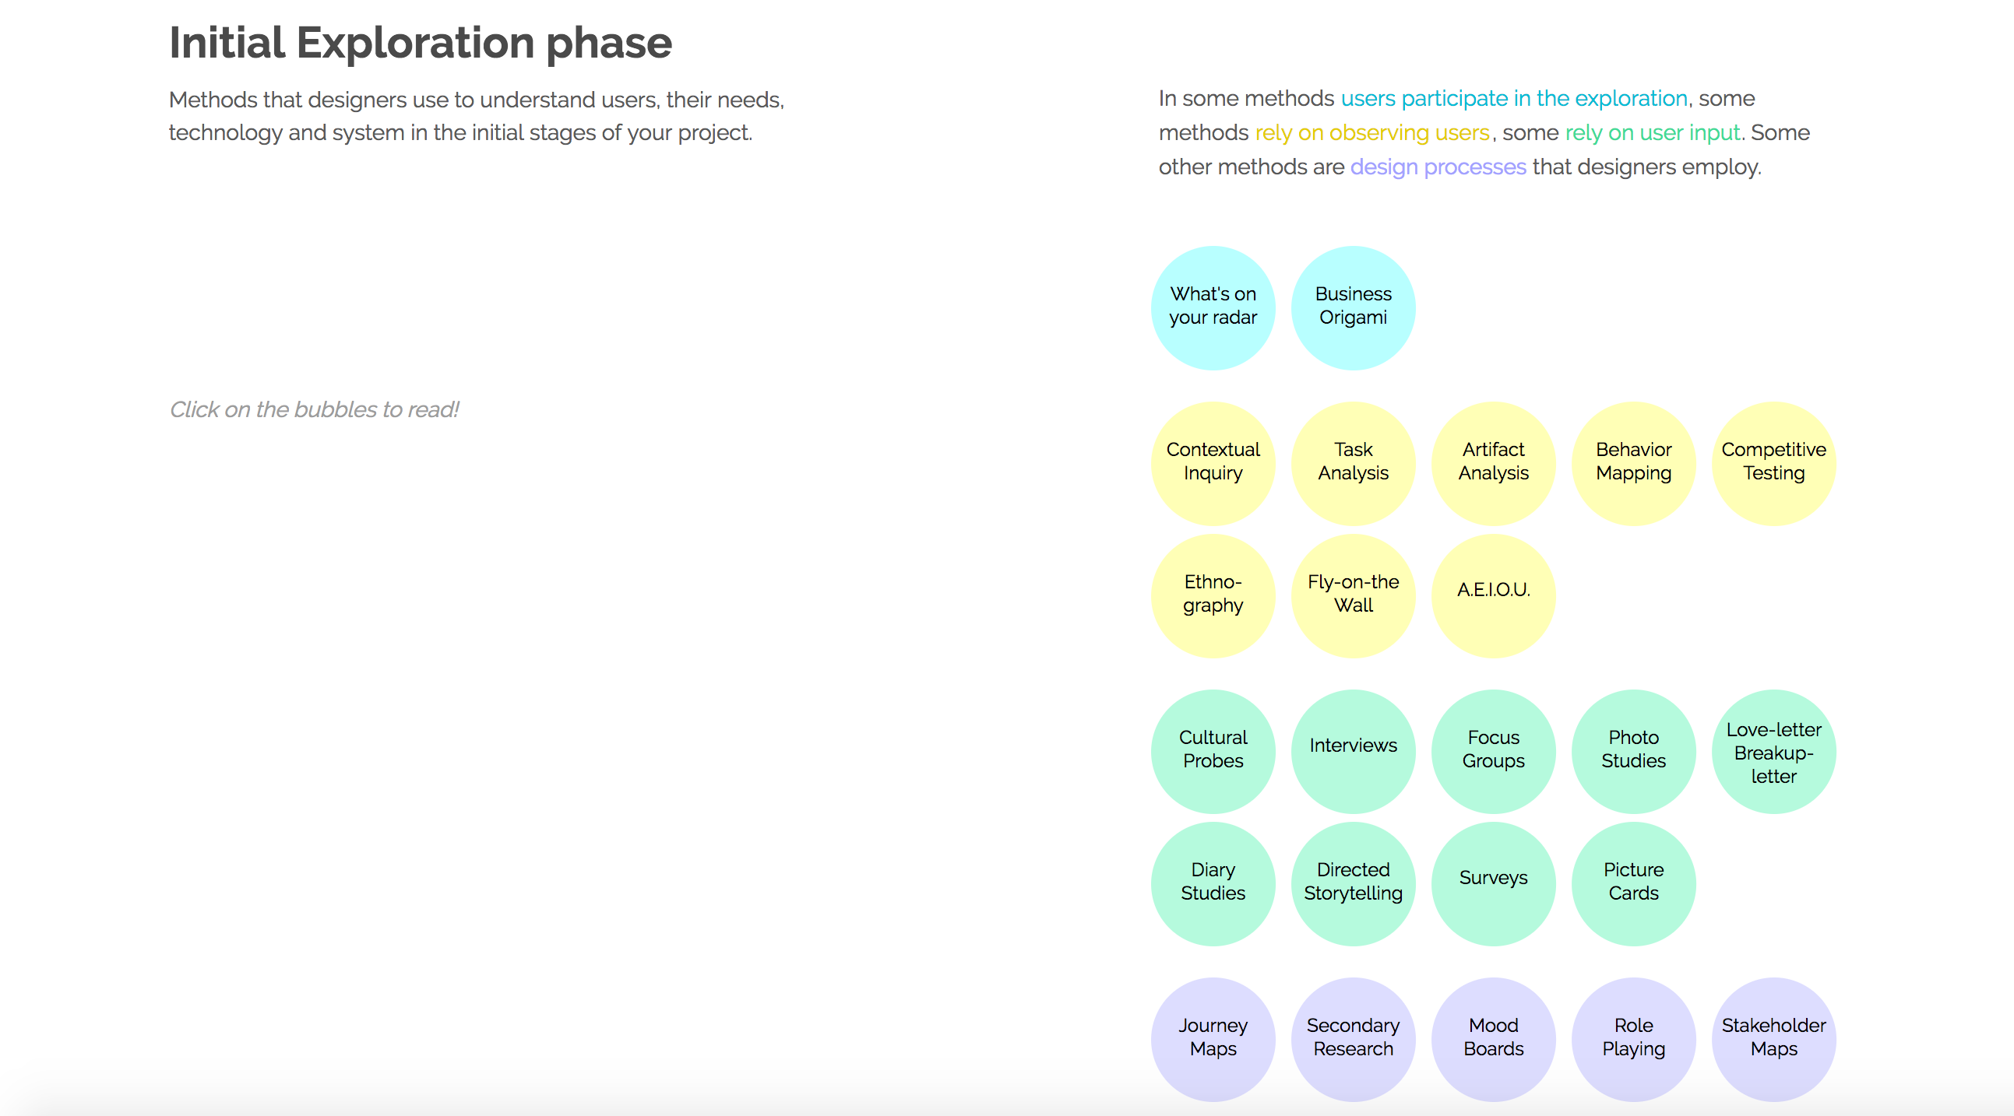

You can click on the bubbles to read information about them

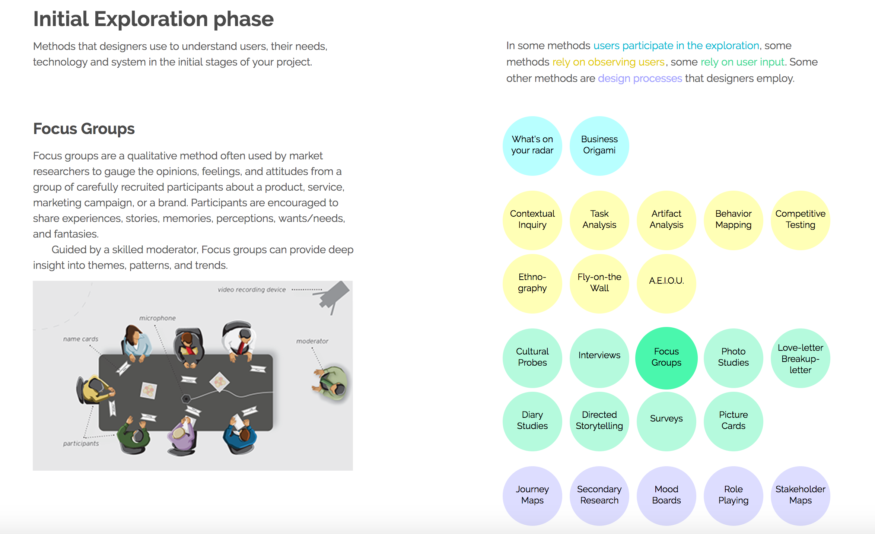

Resources used:

Lynda D3 tutorials, D3.js org sample codes to understand svg elements positioning and editing.

My approach was to understand as many design methods as possible and group them based on certain criteria so that viewers can understand the difference between the methods.

For legend, I have written a paragraph explaining through color coded text, which methods relate to what aspect of project scope (example, if your users have time available then you may use methods that “rely on user input” else you can use those that “rely on observation” or those that are just “design processes”).

I had tried versions of this where the bubbles were all scattered in the 2D space (as in assignment 5) but that had some issues of clear information consumption. Arranging bubbles neatly in rows was remarked as a better alternative when informally tested with some peers.

The most time consuming part was to look up material on the methods either online or books as mentioned below and drawing information from those sources to curate small paragraphs for quick reference.

References:

Universal Methods of Design – by Martin, Hanington

Innovating for People – by Luma Institute

NeilsenNorman group – <https://www.nngroup.com/articles/which-ux-research-methods/>

Medium article – <https://uxdesign.cc/ux-design-methods-deliverables-657f54ce3c7d#.q7o5gectx>

Foot note: It would be great if there is provision for students to get some domain hosting from the university and host this, so that my fellow batch mates can use and refer this when needed. Kindly let me know if such avenues exist!